James Aniciete

STAT 481

Project 2

12/5

2-Way ANOVA Mixed-Effect Model (Balanced Design)

In the setup below, Yijk is the score after a bowling game, Factor A is the impact of the oil pattern, and Factor B is the effects of the bowler.

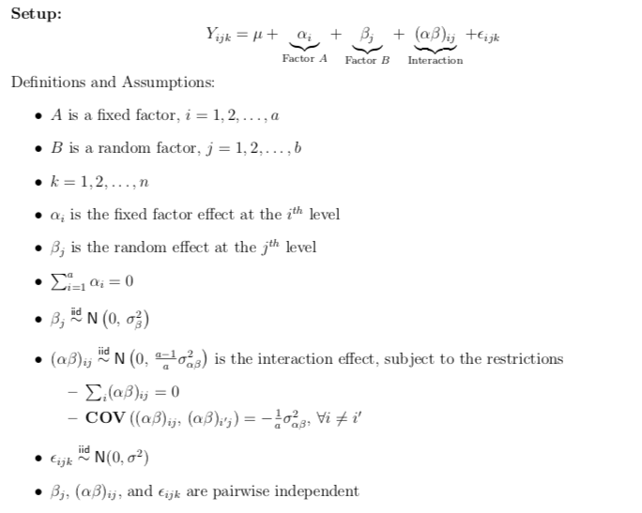

Model Assumption Checks:

* Equal Variance Check: Since there appears to be no pattern in the plot of the residuals against the fitted (yhat) values, we have equal variance of errors.

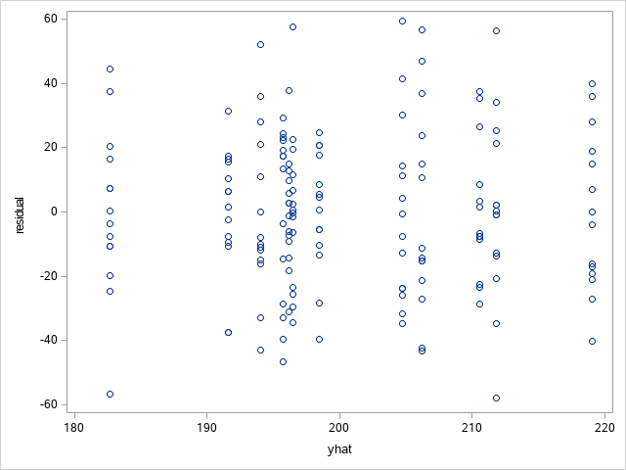

* Independence Check: Since we are not working with time-series data or data gathered in a sequence, there is no need to check for independence of errors. We will assume it is satisfied.
* Normality Check: Since the Shapiro-Wilk p-value = .993606 and we are using a .05 significance level, we do not reject the null hypothesis of the errors following a normal distribution, i.e. the errors do in fact follow a normal distribution.

|  |  |  |  |  |
| --- | --- | --- | --- | --- |
| **Tests for Normality** | | | | |
| **Test** | **Statistic** | | **p Value** | |
| **Shapiro-Wilk** | **W** | 0.993606 | **Pr < W** | 0.6744 |
| **Kolmogorov-Smirnov** | **D** | 0.036087 | **Pr > D** | >0.1500 |
| **Cramer-von Mises** | **W-Sq** | 0.02889 | **Pr > W-Sq** | >0.2500 |
| **Anderson-Darling** | **A-Sq** | 0.196945 | **Pr > A-Sq** | >0.2500 |

Analysis on Interaction Effects and Main Effects

* ANOVA Table:



* Test for Interaction Effects with α = .05:
  + Hypotheses: Ho : = 0 *versus* H1: > 0
  + Test Statistic: FAB = 1.09
  + p-value = .3679
  + Decision: Since p-value > α, we do not reject Ho.
  + Conclusion: Interactions are not present, so we can look at the main effects for the factors.
* Test for Factor A Main Effects with α = .05:
  + Hypotheses: Ho: αi = 0 ∀*i versus* H1: ∃*i* such that αi ≠ 0
  + Test Statistic: FA = 3.14
  + p-value = .1083
  + Decision: Since p-value > α, we do not reject Ho.
  + Conclusion: Factor A main effects are not present.
* Test for Factor B Main Effects with α = .05:
  + Hypotheses: Ho: = 0 *versus* H1: > 0
  + Test Statistic: FB = 3.91
  + p-value = .0817
  + Decision: Since p-value > α, we do not reject Ho.
  + Conclusion: Factor B main effects are not present.

Point Estimates of the Variances

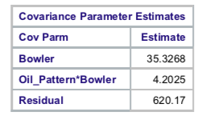

Conclusions

* Since interactions are not present, the bowlers are not expected to be affected by the oil pattern.
* Since Factor A main effects were not present, oil pattern is not expected to effect a bowler’s score.
* Since Factor B main effects were not present, each bowler has the same expected score.
* For bowler to be random means that each bowler was randomly assigned to an oil pattern.

Code:

/* Project 2 */

PROC IMPORT DATAFILE="/folders/myfolders/wpba2009_v2.xlsx"

OUT=data

DBMS=XLSX

REPLACE;

RUN;

/* GLM only used for model assumption checks since it gives the wrong F values */

PROC GLM DATA = data;

CLASS Oil_Pattern Bowler;

MODEL Score = Oil_Pattern Bowler Oil_Pattern*Bowler;

RANDOM Bowler Oil_Pattern*Bowler;

TEST H = Oil_Pattern E = Oil_Pattern*Bowler;

OUTPUT OUT = data1 R = residual P = yhat;

RUN;

/* Equal Variance Check: */

PROC SGPLOT DATA = data1;

SCATTER X = yhat Y = residual;

RUN;

/* Normality Check: */

PROC UNIVARIATE DATA = data1 NORMAL PLOT;

VAR residual;

RUN;

/* ANOVA Table & analysis on interaction effects and main effects (if applicable) */

PROC MIXED DATA = data method = type3;

CLASS Oil_Pattern Bowler;

MODEL Score = Oil_Pattern / CL;

RANDOM Bowler Oil_Pattern*Bowler;

RUN;